Annex G – Description of New System Functionalities by Component

Project Background
The microfinance model was started in Jordan in 1994, and has proved to be a sustainable means of providing access to finance for those at the bottom of the pyramid. As a dedicated credit delivery channel for the un-banked population, MFIs have played a significant role in taking the Financial Inclusion agenda of the Government of Jordan forward. What sets Jordan’s MFIs apart, is they don’t depend on grants or subsidies to provide unsecured loans, instead, using market-oriented solutions that encourage self-reliance and entrepreneurship amongst its clients.
Figure : Jordan population
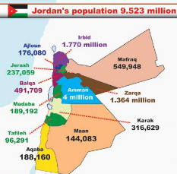
By 2017, the MFIs had a cumulative outreach of 412,000 clients out of a total population of 9.5million. As the MFI industry grows, there is need for greater transparency and better governance to promote the robust development of the sector.
Figure 1: Jordan Population

USAID LENS supports activities to increase access to finance for MSEs in Jordan, and works with MFI on a range of initiatives, such as: introducing new loan products, new practices to assess risk and improve lending, and accessing digital financial services. LENS also supports Tanmeyah, the project is to develop a microfinance industry portal and consolidated database that will enable MFIs and other key stakeholders to have instant access to enhanced analytics of the sector and the identification of new opportunities.

Tanmeyah
Tanmeyah was established and formally registered as a non-profit institution at the Ministry of Industry and Trade in 2007 and was incepted to become the official representative for MFIs, replacing the Microfinance Association of Jordan.

The network’s objective is to develop a sustainable microfinance industry that will become an integral part of the national financial system in Jordan. It will play an active role in supporting the further development of the microfinance industry, providing advocacy and awareness rising on behalf of its members, promoting information and dissemination of developments and trends in the industry. Most importantly it will support the implementation of more structured regulatory environment for MFIs. A new set of MFI guidelines was released by Central Bank of Jordan in 2015, and Tanmeyah is expected to play a key role in ensuring the implementation of these guidelines - Annexure -2.

MFIs Under Tanmeyah Network
The Microfinance sector was formed in 1994 with the launch of a pilot lending scheme in Amman. Today, the industry comprises of eight MFIs. Initially, the sector focused primarily on group and business purpose lending but, based on demand, has evolved significantly to include individual enabling and supporting loans and products such as educational loans, life insurance and business development services. The MFIs in Jordan are non-deposit taking.
Microfinance has proved to be a powerful and effective tool in empowering Jordan’s entrepreneurial poor to increase their family income and contribute to the socio-economic growth. Tanmeyah’ s members prove their capability to grow on sustainable and solid bases through strong operational performance and the sustainability of the services they provide. The following MFIs are registered with Tanmeyah.

- Microfund for Women
- Jordan Microcredit Company “Tamweelcom”
- National Microfinance Bank
- FINCA Microfinance
- Partners for Microfinance -Vitas Jordan
- Ethmar for Islamic Microfinance
- Ahli Microfinance Company
- UNRWA Microfinance

Digital Financial Services
The MFIs are yet to fully explore Digital Financial Services(DFS). Financial Inclusion efforts are being strengthened by Central Bank of Jordan and a new financial inclusion policy was released in Dec 2017. MFIs are expected to join these initiatives and DFS activities will start soon, indeed NMB and AMC have already started mobile banking. The MFI Industry Database will be another important milestone to strengthen government’s proposed financial inclusion directives.

Project Overview

Need for Microfinance Industry Database
Prior to the credit bureau service provided by CRIF, Tanmeyah members relied on a third-party database that tracks and shares MFIs client outstanding loans data. However, as per Central Bank guidelines, and the establishment and licensing of CRIF, some MFIs are now registered with CRIF and individual customer loan details are being consolidated. All MFIs are expected to join CRIF and which provide them with outstanding loans and credit records of individual MFI borrowers and assess their credit-worthiness. The CB system will help curb delinquency rates and assist microfinance institutions to make better business decisions. As such, as soon as the CRIF operated Credit Bureau is fully operational and all MFIs registered, the third-party system currently being used will become of no value to the MFI sector.

The microfinance industry portal and database system will rely on consolidated operational and financial data of the MFIs and not include any personal and/or sensitive information at the individual client level. The MFIs are expected to send quarterly data which comprises of operational and financial data to this industry portal, and which will then be consolidated and processed to be analysed.

The MFI Industry database can be set up to produce analytical reports by geographies, beneficiary types, loan products, age and gender, and other demographics etc. In addition to MFI data, the industry portal is expected to plug-in various other financial and non-financial sector information, such as poverty data, population and statistical information, updates on digital financial services etc. and which will provide the MFIs to conduct enhanced analytics.

Advantages of an Industry Database
The database and centralized web portal will help in sharing various management information reports and key performance indicators. It will provide monthly/quarterly trends on key operational and financial indicators of the microfinance industry at pan-Jordanian and governorates level. Some of the expected advantages include:

- Effective communication and increased visibility on the role the sector plays in national economic growth.
- An easy way to proactively engage between internal and external stakeholders.
- Reports and analysis that can be brought to the attention of government, regulators, bankers, investors, businesses, or the general public.
- Healthy competition and transparency among MFIs.
- It can promote the government’s financial inclusion initiatives i.e. publishing of the National Financial Inclusion Strategy.
- Clear data sets will simplify investment opportunities for domestic and foreign investors
- The portal will act as an information hub and resource centre for the sector
- The database will provide options to upload various third-party data from financial sector and government departments. This would provide an opportunity for MFIs to expand their outreach and provide better financial services

Stakeholder Roles and Advantages
The following are major stakeholders of the proposed MFI sector and database.

Stakeholders | Roles | Advantages from Portal
Microfinance Institutions | - Quarterly Data Upload  - Access to entire portal and data  - Download necessary information’s and documents | - Consolidated information about MFI Sector  - To know other opportunities from Financial sector  - Updates from CBJ and other Regulators  - To know various events in MFI Sector
MFIs Board of Directors | View | - Consolidated information about MFI Sector  - To know regulatory aspects of MFIs
TANMEYAH, MFI Network | - Administrator and custodian of portal and database  - Ensuring data imports from MFIs and Third-Party sources | - Consolidated information about MFI Sector  - Help to produce various sector related reports  - Can be selected as a Self-Regulated Organization for MFI sector
Central Bank of Jordan | View | - Consolidated information about MFI Sector  - Good medium to ensure regulatory compliances
USAID – LENS | View | - Consolidated information about MFI Sector  - Agency which is actively involved for sector development
European Union | View | - Consolidated information about MFI Sector  - Agency which is actively involved for sector development
Prospective Investors | View | - To view reports and analyses MFI performance to take appropriate investment decisions
Funding and Donor Agencies | View | - To view reports and analyses MFI performance to take appropriate investment decisions
Table 1: Stakeholders roles and advantages

IT Systems at MFIs
The MFIs in Jordan are tech-savvy organizations. All MFIs presently use best technology solutions which has real time data integration and processing capabilities and which is crucial for up to date information.

S.No | MFI Name | Loan Tracking System | Financial Accounting System | HR/Payroll/Admin
1 | Microfund for Women | Oracle ADS | Oracle ADS | Mena Itech System
2 | Jordan Microcredit Company “Tamweelcom” | Web Abacus | Web Abacus | Mena Itech System
3 | National Microfinance Bank | DELTA | DELTA | Zetalents System
4 | FINCA Microfinance | DELTA | DELTA | DELTA
5 | Partners for Microfinance -Vitas Jordan | Web Abacus | Quickbooks | Zetalents System
6 | Ethmar for Islamic Microfinance | TrackIT | TrackIT | Mena Itech System
7 | Ahli Microfinance Company | DELTA | DELTA | Mena Itech System
8 | UNRWA Microfinance | Infrasoft | Infrasoft | -NA-
Table 2: Jordan MFIs - IT Systems

All MFIs have dedicated IT teams that monitor technology processes of their branches and head office. All the above solutions are centrally hosted web solutions and which can centrally generate MIS and portfolio reports. Analysis of credit portfolios and financial reports are carried out by respective departments mostly on a daily basis.

MFIs follow stringent measures for data backup and restore process. The servers are maintained by the MFIs own facility. However, third party data centers are available in Amman, the capital. Some of the MFIs plans to shift their servers to such third-party data centers for greater efficiency and to ease their infrastructure management.

Scope of the Project

Introduction

The stakeholders of the MFI industry would like to develop and deploy a centralized portal and database to present MFIs performance in a systematic way. Features of the portal and database include

- The web portal administration will be handled by TANMEYAH.
- The MFI Industry portal will be a GIS, GUI and Data driven portal.
- Be web based on-line portal hosted in a cloud, in a Jordanian data center
- Display updated operational and financial information from the MFIs
- Produce meaningful insights to the sector and to highlight new opportunities for MFIs to increase their outreach

The broad scope of an RFP to develop the MFI Industry Database and portal would include:

- Design, Development, deployment, testing and integration of MFI Industry web portal and database
- Design, Development, deployment, testing and integration of quarterly data set from MFIs
- Development of data upload procedures and systems for various third-party data from Government and non-government entities from time to time
- Capacity building and training on portal management and data upload procedure to designated employees at Tanmeyah
- Handholding and maintenance support for 12 months
- Ensure deployment of industry portal and database to a third-party Data Center identified by Tanmeyah or setting up a data center at Tanmeyah
- The portal will have to develop with latest technologies which will provide 24/7 access to key information on any devices (Mobile, Tablet & PC)

Structure of Industry Portal and Database
The MFI Industry Database consists of a web portal and an advanced RDBMS. The portal should be: intuitive and have dashboard features which can save time, and help analysts to quickly identify the information they need in order to make insightful observations.

Web Portal
A web portal is a specially designed web site that brings information together from diverse sources in a uniform way. The web portal should be developed in Model-View-Controller software architecture pattern which separates the representation of information from the user’s usage. The model consists of data, logic and functions. The view is the output or anything that represents the data, such as HTML pages that show a chart or a diagram. The Model, View and Controller are generated in three separate folders. And in the Model folder generated the model files that base on the concept of active record to accessing the database.

Web portal user interface should be developed in English and Arabic languages.

Layout Frameworks
The portal can be developed in any open source platform such as Bootstrap/ Angular JS/Enterprise Java Spring boot or Apache Spark. These are some of the best open source frameworks presently used across the world.

The portal can be developed in Asp.net Framework 4.0 also. It provides out of the box HTML5 elements such as buttons, table and etc. with designed style from different sources. It should be built to work best on desktops computers and be supported by browsers which are equipped with latest version of the following;

  - Chrome (Mac, Windows, iOS and Android)
  - Internet Explorer
  - Opera (Mac, Windows)

Server Side
It is proposed to use MySQL or SQL Express database. This will be RDBMS complaint which can support relations with one or more tables, and thus data can be stored in a normalized form which can be extracted through complex querying.

Other Device Compatibility
The web portal development has to be compatible with other devices such as Mobile and Tablets which is operated in both Android and iOS operating systems. Google's Android and Apple's iOS are operating systems used primarily in mobile technology, such as smartphones and tablets. Android, which is Linux-based and partly open source, is more PC-like than iOS, in that its interface and basic features are generally more customizable from top to bottom. However, iOS' uniform design elements are sometimes seen as being more user-friendly.

Structure of Industry Portal
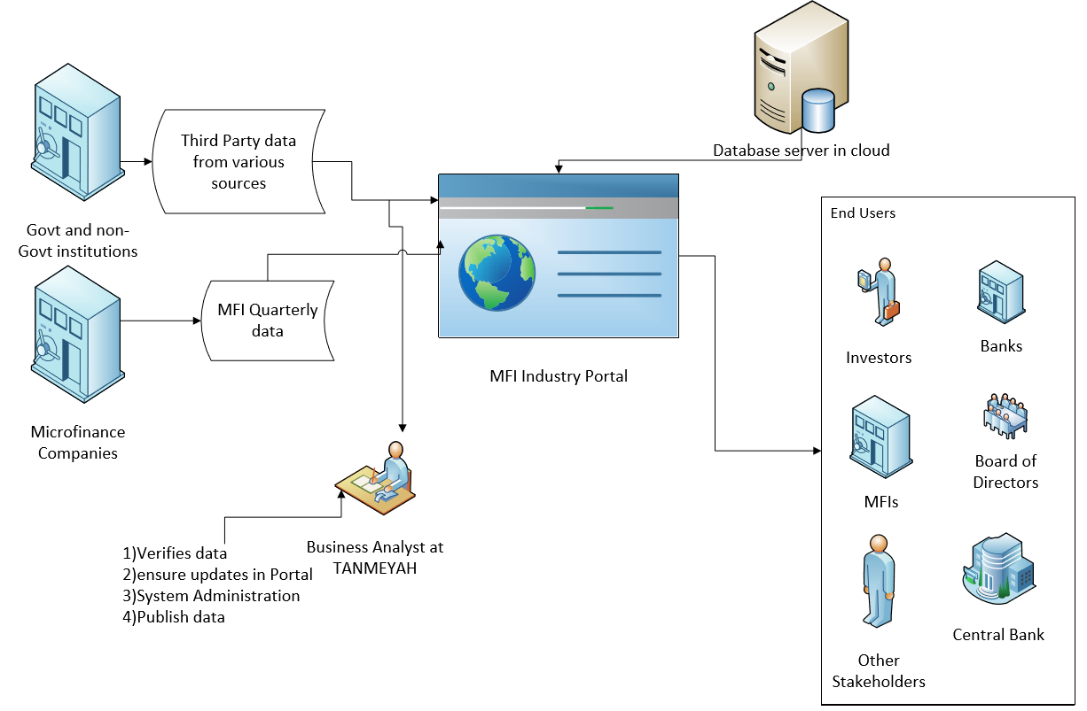
Figure 2: MFI Database Structure
The Industry portal management will be under MFI Network Institution Tanmeyah. The Business Analyst (BA) at Tanmeyah will have to review data received from 1) MFIs and 2) Various third-party sources. The BA will not certify the authenticity or accuracy of data, however, they are expected to identify any data abnormalities. In case any such data abnormalities are found, the BA will have to reach out to respective MFIs and seek clarification prior to authorizing the upload to the portal.

Data Process Flow for MFIs
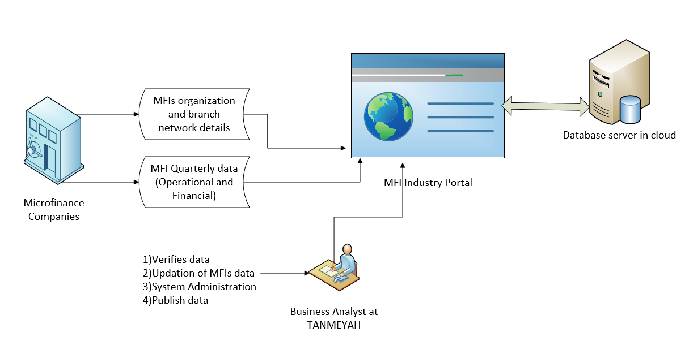
Figure 3: MFIs data flow process

- As a one-time data entry, MFIs will submit MFI Master and Branch details during portal implementation. Subsequently, any new branches are added or to make any changes in branch details, MFIs can login to the portal and make necessary changes. Refer designs in #5.1.6 and #5.1.7
- MFIs will have to send summary of portfolio and financial details every quarter. The data should be sent on a monthly basis also. Refer designs in 5.5.1. Structure of quarterly data format given in Annexure-3 and 4.
- The data files can be CSV, XLS or XML files or the MFIs can directly input data into the portal. MFIs will be provided data entry privileges
- Files will be stored at FTP server. Business Analysts of MFIs (and third parties) are expected to verify and upload the data to the industry portal. Tanmeyah Business Analyst is expected to identify any data abnormalities
- Portal administration will be with TANMEYAH. The portal will have provision for review data submitted by MFIs and approval process System Admin.
- The database and application should be hosted in cloud by Data center companies in Jordan
- Users of the application can view and download reports in various formats

GIS Features
A geographic information system (GIS) should be designed to capture, store, manipulate, analyze, manage, and present spatial or geographic data of Microfinance Companies.

The key indicators such as
- Name of MFI,
- location,
- number of branches,
- total loan officers,
- Net Portfolio,
- Disbursements can be viewed over GIS

The parameters can be customized as per requirements.
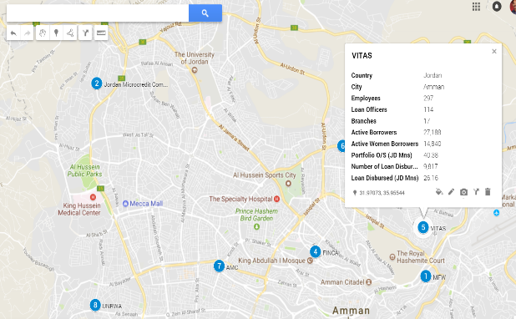
Figure 4: MFIs in Jordan - google map review

The GIS information should be presented into the following levels for each MFI.

- Name of MFI Branch
- Branch Location
- No. of Loan Customers under the branch
- Total Loan Officers Under the branch
- Total Loan Outstanding under the branch

Filtering of GIS data

The information presented in GIS should be dynamic and updated every quarter along with other KPIs of industry database. The GIS features have to be viewed with filtering options by selection of MFIs or Governorates. Subsequently, MFI branch network details can be viewed as per the filtering and selection of MFIs. An example of such GIS map can be referred at http://www.financialaccessmaptz.com/.

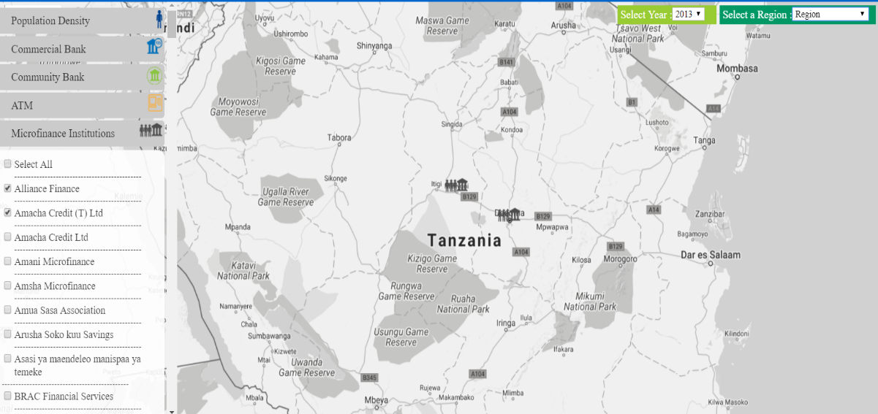
Figure 5: Tanzania MFI Data map, Source Financial access Maps

Third Party Data/Application Integrations
In general, the portal is expected to receive monthly or quarterly data from MFIs in the prescribed data format. The MFI industry analysis will have to be developed from this data. However, the portal is also expected to produce more meaningful insights to the financial sector, thus, the portal should have the facility to accept third party data and produce or compare various dynamic analyses and generate useful reports.

The data uploaded by the Business Analyst has to be reviewed and approved by an appointed person by Tanmeyah.

Example: Analysis of Jordan Data from World Bank
Jordan country data from World Bank is given as an example below. Analysis of MFI Data vs Country data can bring good insights to the MFI Sector. For example, Year 2016 Total GDP for the country is US $38,665 Million and MFIs Portfolio Outstanding is only US $ 304 Million - 1% of GDP.

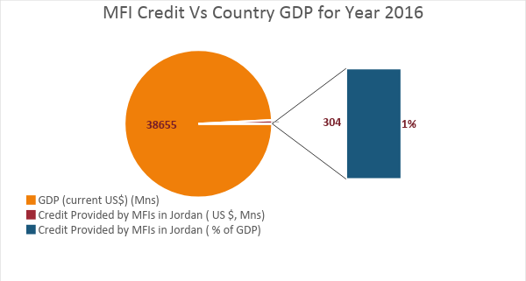
Figure 6: MFI Credit Vs Country GDP

Various analyses can be produced from time to time and the portal will have the facility to upload such third-party data from Government agencies and donor agencies.

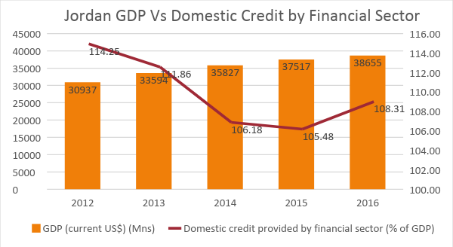
Figure 7: GDP vs Domestic Credit by financial sector
A sample format of third party data is given below.
Series Name | 2012 | 2013 | 2014 | 2015 | 2016
Population, total | 7,992,573.00 | 8,413,464.00 | 8,809,306.00 | 9,159,302.00 | 9,455,802.00
Population growth (annual %) | 5.37 | 5.13 | 4.60 | 3.90 | 3.19
Surface area (sq. km) | 89,320.00 | 89,320.00 | 89,320.00 | 89,320.00 | 89,320.00
Population density (people per sq. km of land area) | 90.03 | 94.77 | 99.23 | 103.17 | 106.51
School enrollment, primary and secondary (gross), gender parity index (GPI) | 1.02 | 1.02 | 1.03 | .. | ..
Improved water source (% of population with access) | 96.90 | 96.90 | 96.90 | 96.90 | ..
Improved sanitation facilities (% of population with access) | 98.60 | 98.60 | 98.60 | 98.60 | ..
Urban population growth (annual %) | 5.66 | 5.42 | 4.88 | 4.17 | 3.46
GDP (current US$) | 30,937,277,605.63 | 33,593,843,661.97 | 35,826,925,774.65 | 37,517,410,281.69 | 38,654,727,746.48
GDP growth (annual %) | 2.65 | 2.83 | 3.10 | 2.39 | 2.00
Inflation, GDP deflator (annual %) | 4.50 | 5.60 | 3.44 | 2.27 | 1.01
Agriculture, value added (% of GDP) | 3.13 | 3.40 | 3.78 | 4.17 | 4.30
Industry, value added (% of GDP) | 30.06 | 29.69 | 29.79 | 29.64 | 28.94
Services, etc., value added (% of GDP) | 66.81 | 66.91 | 66.43 | 66.19 | 66.76
Time required to start a business (days) | 12.50 | 12.50 | 12.50 | 12.50 | 12.50
Domestic credit provided by financial sector (% of GDP) | 114.25 | 111.86 | 106.18 | 105.48 | 108.31
Mobile cellular subscriptions (per 100 people) | 128.17 | 141.80 | 147.80 | 179.43 | 196.31
High-technology exports (% of manufactured exports) | 2.25 | 1.60 | 1.55 | 1.82 | 1.92
Statistical Capacity score (Overall average) | 75.56 | 74.44 | 74.44 | 74.44 | 71.11
Merchandise trade (% of GDP) | 92.57 | 87.72 | 86.88 | 75.45 | 69.11
Net barter terms of trade index (2000 = 100) | 83.72 | 77.91 | 74.85 | 79.33 | 87.53
External debt stocks, total (DOD, current US$) | 18,484,353,000.00 | 23,173,392,000.00 | 24,281,432,000.00 | 25,719,578,000.00 | 27,125,916,000.00
Total debt service (% of exports of goods, services and primary income) | 6.36 | 6.24 | 8.18 | 14.32 | 17.23
Personal remittances, received (current US$) | 3,848,309,859.15 | 5,342,816,901.41 | 6,369,718,309.86 | 5,348,309,859.15 | 4,374,647,887.32
Foreign direct investment, net inflows (BoP, current US$) | 1,548,450,704.23 | 1,946,597,204.04 | 2,178,309,859.15 | 1,600,281,690.14 | 1,538,873,239.44
Net official development assistance and official aid received (current US$) | 1,157,490,000.00 | 1,400,330,000.00 | 2,697,140,000.00 | 2,150,000,000.00 | ..
Table 3: Jordan country data from World Bank

Other Third-Party Data Integrations
Similarly, other third-party data may be uploaded and so the portal should have a facility to upload data with the data headers that can be created and renamed dynamically. The portal facility is to be designed in such a way that it can add records to a dynamic data table as defined by the Database Administrator.

Co-Location Data Centers in Amman

Currently there are 5 colocation data centers in Amman.

- VTEL Jordan Data Center
- Zain Jordan Co-Location DC
- Kulacom DC
- Damamax DC
- iLevant-Amman

MFI Industry portal has to be hosted in any of the above data centers. The costing needs to be worked out based on the technical requirements of the portal, such as requirements for 1) Processors 2) Memory 3) Hard Disk 4) Rack Requirements 5) Dedicated Bandwidth 6) Firewall etc.

Modules of Industry Portal

The MFI Industry Portal is expected to be a dynamic portal with rich features of Graphical User Interfaces (GUIs), Dashboard and GIS features. A sample snapshot of Industry Portal is given below. By developing such an industry portal, MFIs and its stakeholders can keep up-to-date with sector analysis, news, announcements, and events etc. The portal will have to be developed with latest technologies which will be providing 24/7 access to key information on any devices (Mobile, Tablet & PC).

The key modules of the portal are

- Home
- About Us
- MFIs
- Reports
- Data Upload
- Resource Center and
- News and Events

The Modules should have the following Sub-Menus.

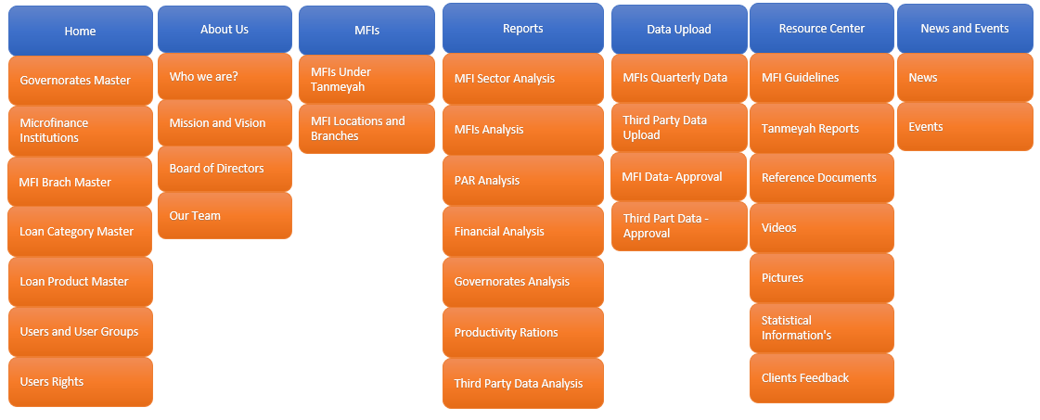
Figure 8: Modules and Menus
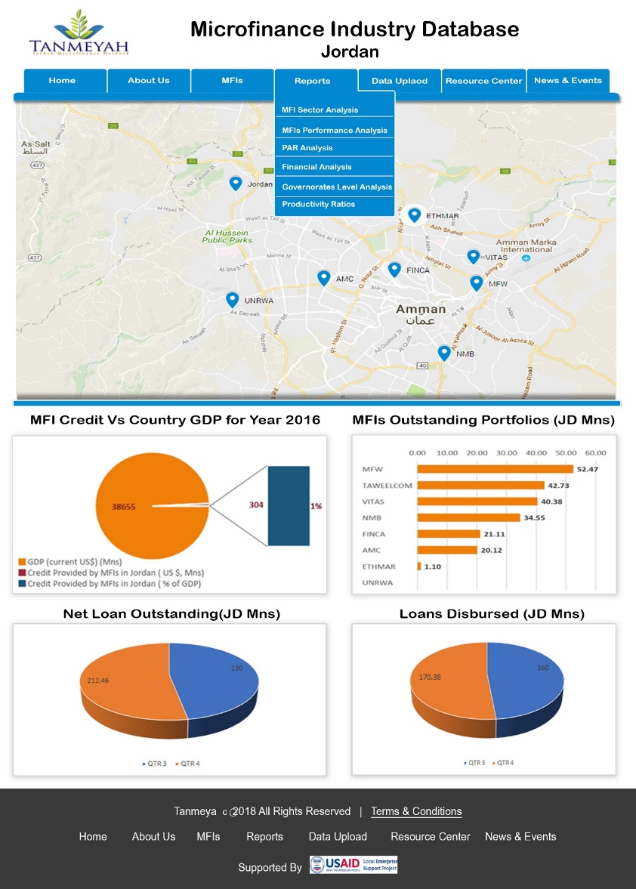
Figure 9: Industry Portal - Sample Design

Home/Master Modules
The Master module is to accept the list of inputs for each unique Master that is created in the system. The data once defined in Master Module should be used subsequently at different modules and other features defined across the portal.

In general, Master Module data entry is expected at the initial phase of implementation and as a one-time process. However, any changes or additional data should be entered whenever required. The rights of data entry at Master Module lies with System Admin. However, MFI users can enter master data pertaining to their MFIs such as MFI Master and Branch Master.

User Login Process

MFIs has to register with the portal to have full access for quarterly data upload and make data entry and corrections for MFI Master and MFI Branch Masters. Other users such as CBJ, donors, investors, the general public etc. need not to have Login process. They can view all features of the portal but can’t access the data.

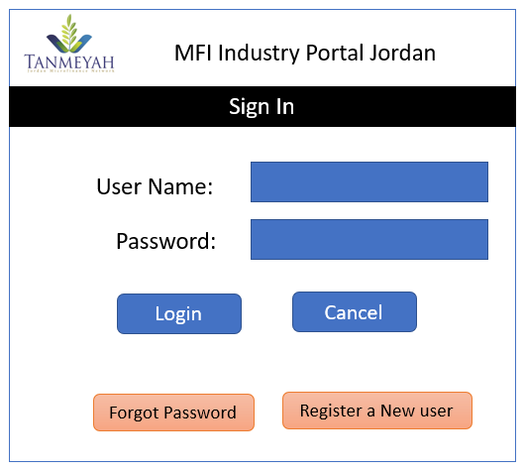
Figure 10: Login Screen

New Users has to click on “Register a New User” and provide the below given details.

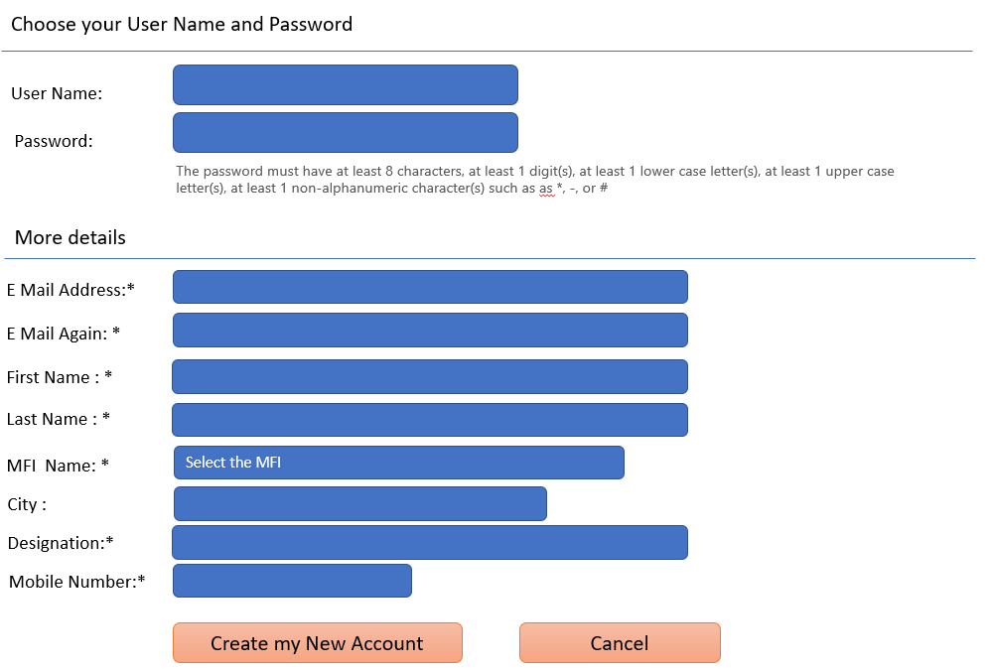
Figure 11: New User Creation

The request will be received by System Administrator at Tanmeyah and verification process to be conducted before creation of User Id. The portal will send a test email to the new user and who should click the link to conform the mail id given during registration.

Users and Permissions

All features of the portal can be viewed by anyone without any login credentials except Data Upload Process. Quarterly MFI data upload is allowed only for MFIs. Third party data upload will be restricted to the System Administrator.

User Registration and Credentials are required for MFIs to upload quarterly data and make changes in their respective MFI Master and Branch Masters. Hence, only two types of Users are required in this portal.

- System Administrator - is Super User and has all privileges for add, delete, modify and view options
- MFI Users - has privileges for adding and full access rights on Data Upload, MFI Master and MFI Branch Master

System Admin Rights

- Appearance: Administrator can change the themes and look and feel of the home screen as well as the internal pages
- Users Rights: Admin can create rights to users both individual and group wise.
- Creating Groups: Admin can create many groups as per the requirement. Group benefit was admin can apply at a time of the features to group users.
- Events: Admin can create the many events without limit and can circulate it to the users as well.
- Reports: Admin can generate many reports like user activities, third party data analysis, creation of new reports and analysis etc.
- Development: This platform should allow to admin to development changes within the portal pages.
- Plugins: Portal providing the rights to admin adding plugins to portal as per the requirement. This is mostly to define third party data integrations.
- Backup: Admin has a right to take a backup entire portal
- Restore the Backup: Admin has the right to restore the backup for required time to restore the earlier time.
- Users Permissions: Admin can change / give rights to play the roles
- Creating users: Admin can create users from backend individual and bulk uploads.
- Control: Admin can control the entire site.
- Customize pages: Admin can customize the dashboard and site pages too

MFI User Rights

- Users can upload quarterly data with respect their MFI
- Users can update and change MFI Master and Branch Masters
- Users can upload images, videos, files and share with respect to their MFI details.
- Change Password: A user can change the password by himself

Governorate Master
Governorate master will be used to define various Governorates in Jordan.
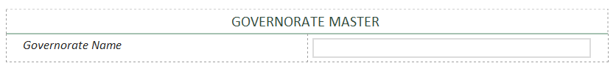
Figure 12: Governorate master

MFI Master
The MFI Master is used to define the list of MFIs, locations and their respective contact details, interfacing with all other modules. This module can be used in following cases:

- To define the list of MFIs, concerned Directorates and their contact details
- To Add/ delete new/existing MFIs from the Master table
- To edit existing MFI data from the Master table
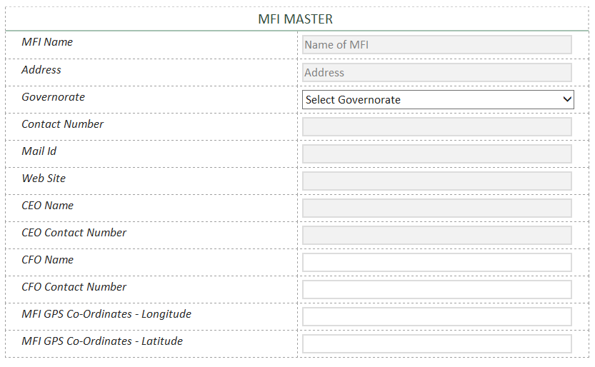
Figure 13: MFI Master design

Adding MFI Branches
MFI Branches can be added using this option. Branch longitude and latitude can be captured to locate the Brach using GPS features.
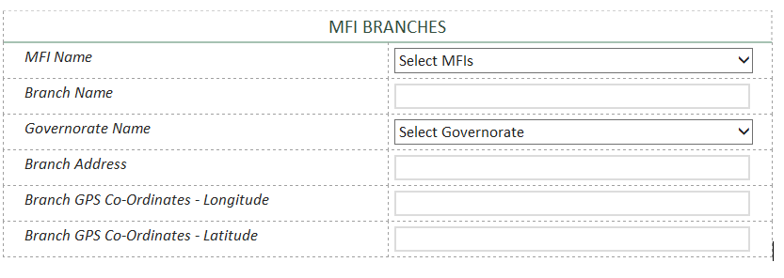
Figure 14: MFI Branches Master

Note: The branch data can be uploaded into portal as a one-time activity during implementation. This is part of data initialization/migration process. Similarly, MFI Master data can be uploaded as a one-time activity by project implementation team.

Loan Category Master
This master can define various loan categories. Loan category can be 1) Agriculture 2) Non-Farm 3) Consumer 4) Housing 5) Women Empowerment 6) Personal Loans etc.
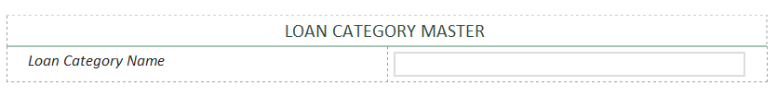
Figure 15: Loan category design

Loan Product Master
Loan Product Master will be used to create Loan products and loan product categories
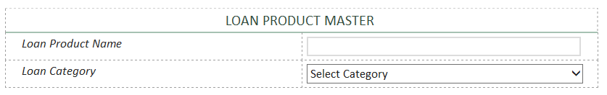
Figure 16: Loan products design

About Us
This module will be used to present details about Tanmeyah and a brief introduction about the portal. The Following details will be captured under this section.

- Who we are?
- Mission and Vision
- Board of Directors of Tanmeyah
- Membership process and procedures

MFIs those who want to become members of TANMEYAH need to know the rules and procedures. Portal can brief about Membership process, Benefits, Eligibility Criteria, Membership fees etc.

Microfinance Institutions

MFIs in Jordan
A brief note about each MFI registered under Tanmeyah will be presented under this module. The brief history of MFIs, Leadership, Vision, Mission, key features of Products and any other highlights about the MFI.

MFIs Branch Network
Name and Locations of MFI branches will be presented under this feature. The GIS map will be shown while highlighting MFIs and its branches. This will highlight the MFIs outreach.

Reports
Once the quarterly data uploaded into the portal after necessary verification by portal administrator, the data will be processed to produce required analysis and dashboard preparation. The following analysis can be part of the portal dashboard and reports.

MFI Sector Analysis
Consolidated reports of MFI sector will be represented in this section. The data will be presented as a comparison between two quarters with in the year and between two years by end of year.

- Total Loan Outstanding (Net)
- Average Loan Outstanding
- Total Loan Disbursements
- Average Loan Disbursements
- Outstanding Customers
- Portfolio Analysis – Net Vs Gross
- Total Number of Employees Vs Loan Officers
- No of Branches
- Outstanding Borrowers Vs Women Borrowers Vs Youth

MFIs Portfolio Analysis
This section covers the comparative analysis of MFIs in Jordan as per the classifications given below:

- Loan Portfolio – Outstanding
- Loan Disbursements
- Average Loan Outstanding
- Average Loan Disbursements
- MFI Growth Rate Analysis as per net loan portfolio from present period to last reporting period

PAR Analysis
This section explains Principle at Risk (PAR) analysis:

- PAR 30 for All MFIs - Present Quarter vs Previous Quarter
- PAR 90 for All MFIs
- PAR 180 for All MFIs
- PAR 30 Analysis for each Governorates
- PAR 90 Analysis for each Governorates
- PAR 180 Analysis for each Governorates

Financial Analysis
This section covers financial performance of the MFI sector in Jordan. Individual analysis of MFIs will not be circulated.

- Asset Analysis
- Total Assets Vs Outstanding Borrowings
- Liabilities Analysis
- Equity Distribution
- Ratios Analysis – FSS, OSS, ROE and ROI

Governorate Level Analysis
Jordan has 12 Governorates. Each Governorate level analysis will be carried out in this section for the below given parameters.

- MFI Branch Network
- Gross Loan Portfolio
- Disbursements
- Outstanding Customers
- Average Loan outstanding per account per Governorate
- Average Loan disbursed per account per Governorate
- Total borrower’s vs Women Borrowers per Governorate

Productivity Ratios
This section covers various productivity ratios such as:

- Average gross loan portfolio per loan officer
- Average gross loan portfolio per branch
- Borrowers per Loan Officer
- Borrowers per Branch
- Microfinance Clients Vs Country population
- Microfinance Clients Vs Other Financial Institutions

Data Upload

Quarterly Data Upload from MFIs
This module will be used to upload quarterly data from MFIs. The data structure provided in Annexure. Data can be upload through any of the following file structure such as .CSV or .XML or .XLS.

MFI quarterly data is uploaded by the MFIs. In case of data rejection due to missing of mandatory fields and data type differences, a log file will be created along with file rejection. MFIs can review the log file and make necessary corrections in data file.

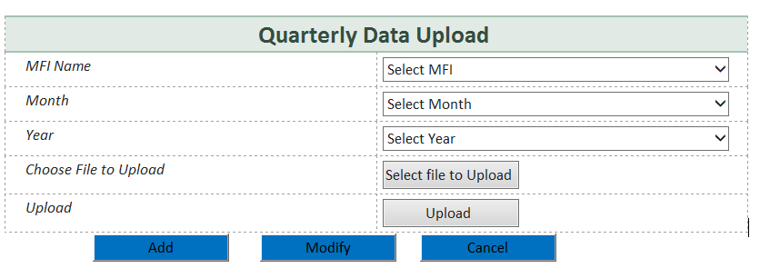
Figure 17: Quarterly data upload design for MFIs

Third Party Data Upload
This facility is to be used for third party data upload mentioned in #4.8. Since there is no pre-fixed data structure the data has to be uploaded in a dynamic way. The number of columns must be defined prior to the data upload. First Row will be treated as column headings. The file name is to be provided by the user. Category of data and source are to be provided.
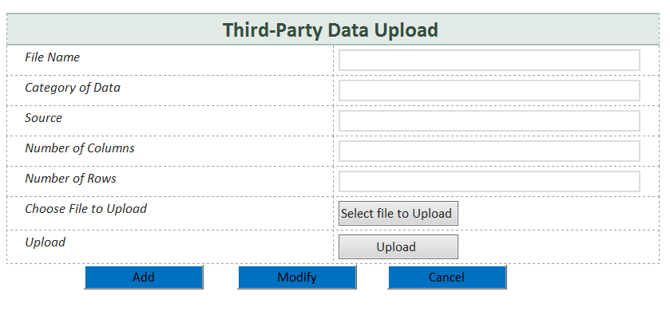
Figure 18: Third party data upload design

Review and Approval MFI Data
The Quarterly data submitted by MFIs have to be reviewed and approved by System Admin or Business Analyst from Tanmeyah. The portal should have provision to approve the data and then used in various report and analysis. In case of any discrepancies, SA /BA will have to sort it out with respective MFIs.
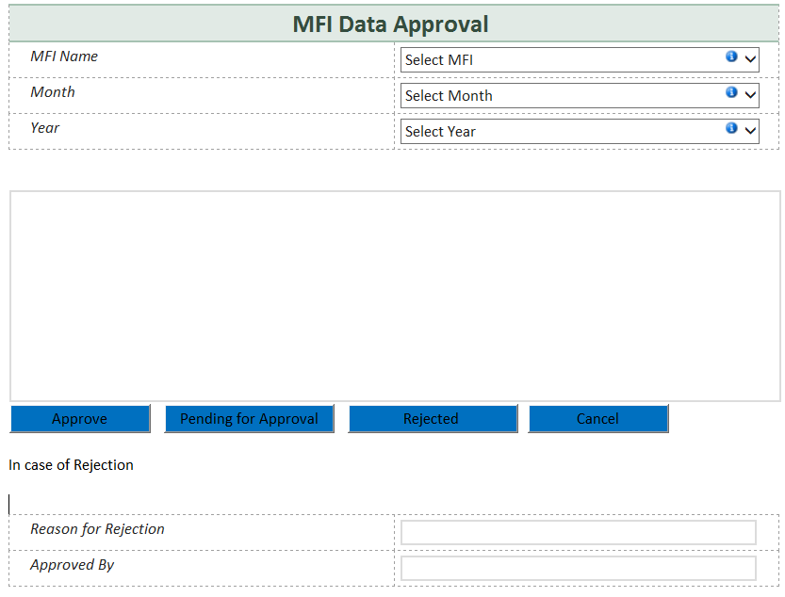
Figure 19: MFI Data Approval Process

Review and Approval of Third Party Data
Third party data uploaded by Business Analyst needs to be reviewed and approved by the designated members from Tanmeyah. The data will be used for any analysis only after such approval. The portal should have facility to view all such files which are pending for approval. In case any data rejected, the reason for rejection will have to be recorded.
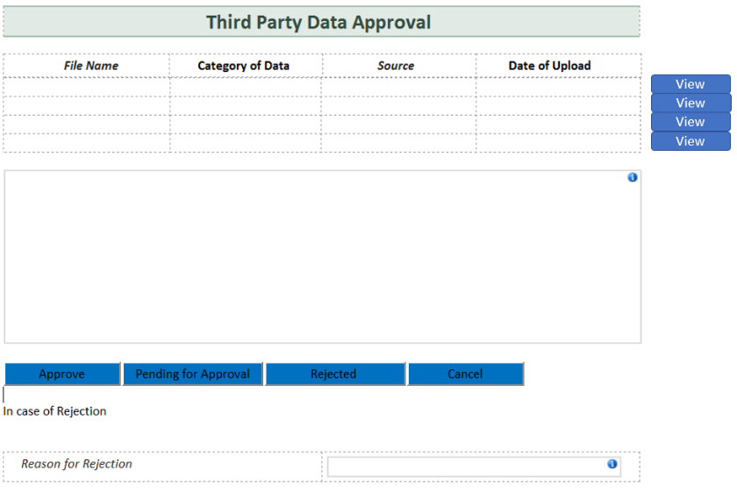
Figure 20: Third Party Data Approval Process

Resource Center
The portal will also be a resource center for Jordan MFI Industry. Some relevant documents that could be added to the portal are:

- MFI Guidelines from Central Bank of Jordan
- TANMEYAH Reports and Analysis
- Industry Relevant Reference documents
- Relevant Videos and pictures
- Statistical information's
- Feedback from Customers

News and Events
Various news and events related to MFI Industry will be added under this feature.

The Financial Access Point data has been overlaid on a population distribution dataset to determine the proximity of financial access point to where people live and transact in Tanzania. The link given in this report only for a reference purpose.
Source: http://databank.worldbank.org/data/reports.aspx?source=2&country=JOR#

